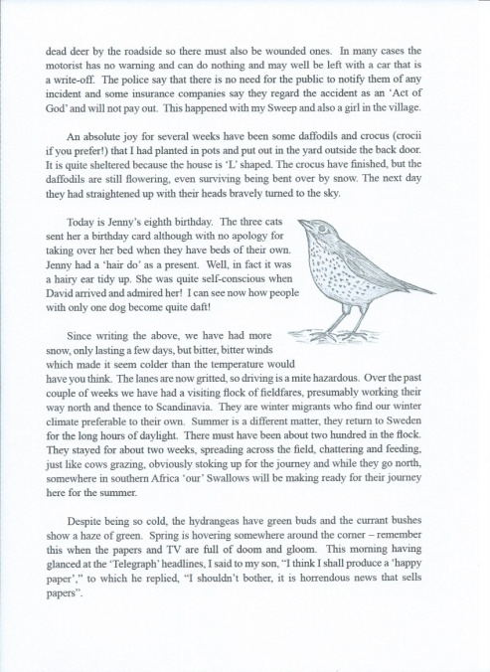
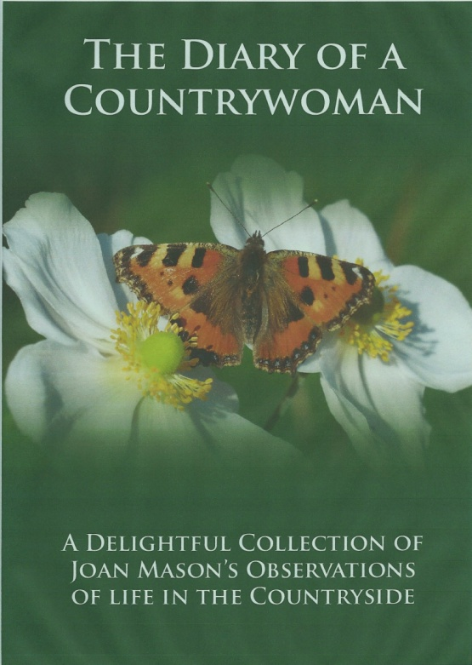
DIARY OF A COUNTRYWOMAN

This book has been printed in memory of Joan Mason.
It is a collection of her observations of the countryside which were featured in the IFRR Magazine and much loved by us all.

A few illustrations have been added and it is hoped that it will be enjoyed by you all.

Joan touched so many lives that the IFRR wanted to pay our tribute to such a wonderful lady.

£5.25 inc p&p

*Overseas £7.00 inc p&p

ORDER FORM

Please send me .........................copies of Diary of a Countrywoman @ £5.25

Name.......................................................................

Address...................................................................

..................................................................................

.........................................................................POST CODE..........................................

Tel: .......................................................

Please make cheques payable to IFRR and send to

IFRR Book
Silvermere Cottage
11 Lower Stanton St Quintin
Chippenham
Wilts
SN14 6BY Tel. 01666 837087 email mrhaines@btopenworld.com

The Book will be available in October.

