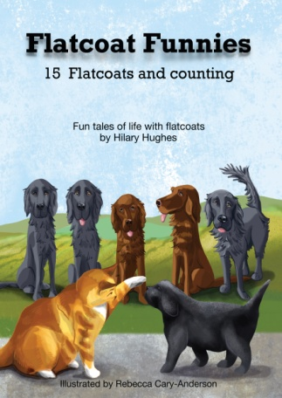
To Order FLATCOAT FUNNIES

This wonderful little book has been so generously donated to the IFRR
By Hilary Hughes.
Brilliantly illustrated by Rebecca Cary-Anderson.
It will make a lovely gift or just something to treasure.

£12.00 inc p&p*

How many books?...............................................

Name...............................................................................
*Post and Packing

EU Countries
Please add £3.00
Per Book

United States of
America
Please add £5.00
Per Book

Address....................................................................................

................................................................................................

....................................................................................................

Post Code...................................................................................

Telephone No...........................................................................

Email .......................................................................................

If you would like to pay by Bank Transfer details are Sort Code 30-95-75 A/C 01532599 *
A/C Name IFRR
Please use reference ‘Flatcoat Funnies’

Please make cheques payable to IFRR and send to

IFRR - Flatcoat Funnies
Silvermere Cottage
11 Lower Stanton St Quintin
Chippenham
Wilts
SN14 6BY Tel. 01666 837087

*If you are paying by Bank Transfer you can email your order form to ifrrrehoming@gmail.com
* Post and Packing – for multiples of more than 2 books ordered from outside UK please contact us for postage.

